**Defend the Republic**

**Spring 2022**

|  |  |
| --- | --- |
| Hosted By: Indiana University  Bloomington, IN | Sponsored By: Dr. Michael Qin  Office of Naval Research, Code 34 |

Participants:













POC for Participation: Samantha Lawrence, NSWC Crane, [Samantha.Lawrence@navy.mil](mailto:Samantha.Lawrence@navy.mil)

Table of Contents

1. Introduction 3

2. Participation 3

3. Visitors 3

4. Dress code 3

5. Game Play Regulations 4

5.1. Qualification 4

5.2. Game balls 4

5.3. Goals 4

5.4. Scoring 4

5.5. Team Vehicles & Fielded Equipment 5

5.6. Helium Supply 5

5.7. Game Start 6

5.8. Operation 6

5.9. Manual Interventions 6

5.10. Defensive Goal Tending 6

5.11. Overtime 6

5.12. Referee Balloon 6

5.13. Championship Round 7

6. Location 7

7. IU MESH High Bay - Field Set-Up 8

8. Supplies 9

8.1. Shipping Items 9

8.2. Router 10

8.3. Tools 10

9. Facility Safety Rules 10

# Introduction

Defend the Republic is a force-on-force test event that pits two teams of Lighter Than Air (LTA) vehicles together in a match where each team attempts to capture and score helium balloons in their opponent’s goals. The purpose of this event is to push forward drone research in the areas of multi-agent swarming, communication, and payload design. LTA vehicles stay afloat for longer periods of time, making swarming algorithm and sensor research easier and safer to test. By using LTA vehicles, teams are limited in payload capacity, which will force them to optimize their sensors and control systems into the least viable product.

# Participation

The following list includes the slated participants for the Spring 2022 competition. There is no entry fee. If interested in participating, please reach out to Samantha Lawrence ([Samantha.Lawrence@navy.mil](mailto:Samantha.Lawrence@navy.mil)). There are regular meetings for team leads to collaborate and discuss that interested parties are welcome to join.

# Visitors

Visitors interested in funding teams, fielding teams, or simply curious are welcome. All visitors must reach out to Samantha Lawrence ([Samantha.Lawrence@navy.mil](mailto:Samantha.Lawrence@navy.mil)). Visitors who fail to pre-register may be turned away at the door. Visitors are also subject to dress code requirements.

# Dress code

All participants and visitors on the floor are encouraged to wear only the colors white, gray, khaki, or black. The wearing of red, blue, yellow, orange, or green will NOT be permitted due to the autonomous nature and sensing of the LTA vehicles.

# Game Play Regulations



## Qualification

* + 1. All teams must complete a qualification round prior to being permitted to play. The qualification round requires that each team score a goal in unopposed game play in under 30 minutes.
    2. If a team fails to qualify on day 1, they may try again in the morning of day 2, etc. until the end of the week.
    3. Once a team qualifies, they will be permitted to play their scheduled games for that day and the rest of the week.

## Game balls

* + 1. Five or more game balls will be in the playing field at any given time.
    2. Game balls consist of the following: https://www.amazon.com/dp/B07X242MTL
    - They will be weighted to be approximately neutrally buoyant. Note: They will not be perfect, thus adding to the challenge. If they fall back down, we will adjust their weight and knock them upwards. If they get stuck on the ceiling, we will put another balloon in the air.

## Goals

* + 1. Each team will defend their Life, Liberty, & Property, or three hoops mounted from the ceiling in each end zone.
    2. Hoops will consist of one circle, square, and triangle in each end zone. These will be made with ½” plywood and coated with retro-reflective tape. One end of goals will be orange. The other end will be yellow. The tapes used will be as follows:

https://www.walmart.com/ip/Oralite-Reflexite-V98-Microprismatic-Conspicuity-Tape-2-in-x-15-ft-Fluorescent-Orange/101885580

https://www.amazon.com/Oralite-Microprismatic-Retroreflective-Conspicuity-Tape/dp/B0041PCG2A

* + - 1. Goal tags – Will not be used (photos of them are from previous events).
      2. Circle – ½” plywood, 36.5” inside diameter, 4” wide frame.
      3. Square – ½” plywood, 38” on the inside of each side, 4” wide frame.
      4. Equilateral Triangle – ½” plywood, positioned point down, inside leg length 55”, 4” wide frame.

## Scoring

* + 1. A goal is made via pushing a game ball through any opponent goal in either direction (1 point awarded for each goal scored).
    2. Teams may not push a game ball through one of their goals (Own goal = -1 point).
    3. Once scored, the LTA vehicle shall come down for the game ball removal / release, and then return to game play from the center of the field. Alternatively, the LTA vehicle may release the game ball and travel to the middle of the field to ‘reset’ prior to continuing game play. A LTA vehicle retrieved for game ball removal may be released immediately back into the game at the center of the field.

## Team Vehicles & Fielded Equipment

* + 1. For all vehicles, negative buoyancy may not exceed 100 grams.
    2. LTA vehicles will not be considered within game play if it is tethered, resting on the ground, or resting on the ceiling.
    3. Each team must have a red fleet and blue fleet (or a way to swap colors).
    4. Each vehicle must be at least 70% red or blue. The opponent’s color must not appear on the balloon.
    5. Sensory tools / equipment may be placed on walls or scoring goals by the LTA vehicles at the start of game play.
    6. A team may not place anything on a goal they are defending.
    7. Any placed equipment shall be removed between games by the team that placed them via the referee balloon or a LTA vehicle. Any equipment placed on goals must be removed at the end of each half.
    8. No active adhesives are permitted for game play.
    9. No purposefully destructive attack methods are permitted. Bumping into one another is not considered destructive. If a LTA vehicle is ‘propped,’ the team which lost an asset is permitted to select two assets of the other team’s to hold until the end of the game.
    10. No one LTA vehicle can contain more than 50 cubic feet of helium.
    11. There are no shape restrictions.
    12. All effects leaving a team’s tent (RF, light, sound, etc.) may only interact with that team’s own LTA vehicle.
    13. Due to the infancy stage of the autonomy, no signals meant to disrupt the opponent’s LTA vehicles may be used.

## Helium Supply

* + 1. Each team will be provided quantity 2 tanks of 220 cubic feet of industry quality helium. Please note, this is different than helium one would obtain from a party store (less buoyant).
    2. The provided helium is determined to be for 200 cubic feet of helium per each fleet with a 10% buffer for mistakes, leaks, popped balloons, etc. throughout the week.
    3. There will be a minimum of 2 helium tanks on standby in case it is needed due to a catastrophic accident (e.g. a team leaves their regulator open and they lose all their helium). In this case, the team will receive a new tank to continue playing.

## Game Start

* + 1. Coin toss for sides.
    2. Team members can toss their LTA vehicles once the referee confirms start of game play and starts the clock.
    3. LTA vehicles must be launched from the center of the field. The operators may select others to launch the LTA vehicles for them.

## Operation

* + 1. Game play will consist of two 30 minute halves with a 20 minute half-time.
    2. Each team may have only 2 operators. An operator is defined as any person who provides external inputs or controls to the vehicle.
    3. During game play, the operators will only be permitted to directly control their fleet during the first 30 second interval within every 5 minute increment.
    4. The 30 second ‘hands on’ period will occur at the same time for both teams.
    5. The official will announce manual & autonomous time periods.
    6. Operators may have visual line of sight of their assets during game play.
    7. Batteries may be swapped, but this will be restricted in future events.

## Manual Interventions

* + 1. If a LTA vehicle must be pulled from game play, it may be returned to the team for repairs and returned to the game during the next ‘hands on’ manual period. Upon return, it must be launched from the center of the field.
    2. Each team may have one ‘runner’ who may use a referee balloon to retrieve stuck or dead LTA vehicles.
    3. At any time, a LTA vehicle can be manually controlled in order to pull it from game play.

## Defensive Goal Tending

* + 1. While defensively tending a goal, a LTA vehicle must maintain a loitering distance of approximately 1 foot or more from the goal unless it is actively intervening with the opponent’s attempt to score. At no time may a LTA vehicle insert itself, grab the goal, or brace itself against the goal.
    2. If a goal tending LTA vehicle makes contact with the goal 3 times within the 4.5 minute autonomous period, the operator will be instructed to intervene and manually drive it away.

## Overtime

* + 1. If both teams are tied at the end of the last 30 minute half, the game will continue into sudden death overtime.

## Referee Balloon

* + 1. The referee shall provide two referee balloon assemblies (large balloon on a string) for teams to pull lost balloons off the ceiling.
    2. Equipment not retrievable (due to pit locations, etc) will be retrieved once it comes down due to loss of helium. This may take a week or more. IU personnel will dispose of it at that point or if desired, a team can prepay for a shipping label and have the equipment shipped back to them.
    3. Do not use packing tape on the referee balloon.

## Championship Round

* + 1. Teams will be ranked by most games won. Tie-breaker is head to head competition. Second tie-breaker is goal differential.
    2. Top two teams will compete Friday morning.

# Location

Indiana University MESH

(Defined on Google Maps as “Center for Exploration of Energy and Matter (CEEM))

2401 N Milo B Sampson Ln,

Bloomington, IN 47408

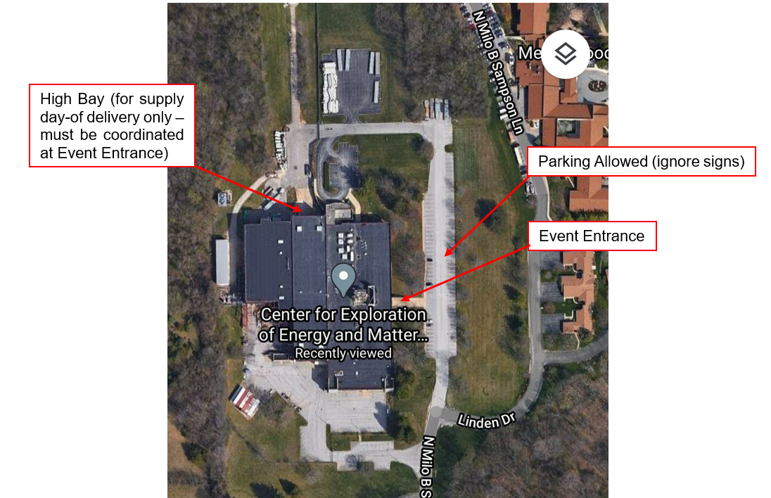

Figure 1: Google Maps view of IU MESH. Parking, event entrance, & supply drop-off areas identified.

# IU MESH High Bay - Field Set-Up

There is airflow at various points that will affect flight, which are roughly defined in Figure 2 by the blue arrows. Draft direction, strength, and overall flow varies throughout the day and week based upon temperature and humidity differentials from the facility to outside. Team work stations will be along the walls of the high bay area. The large door in the far, north side of the photo should be used to bring in all supplies and tools once coordinated with the personnel at the Event Entrance, identified in Figure 1. Figure 3 provides a top view of the MESH facility with approximate goal locations. Notice, the goals are not mounted in line with each other.

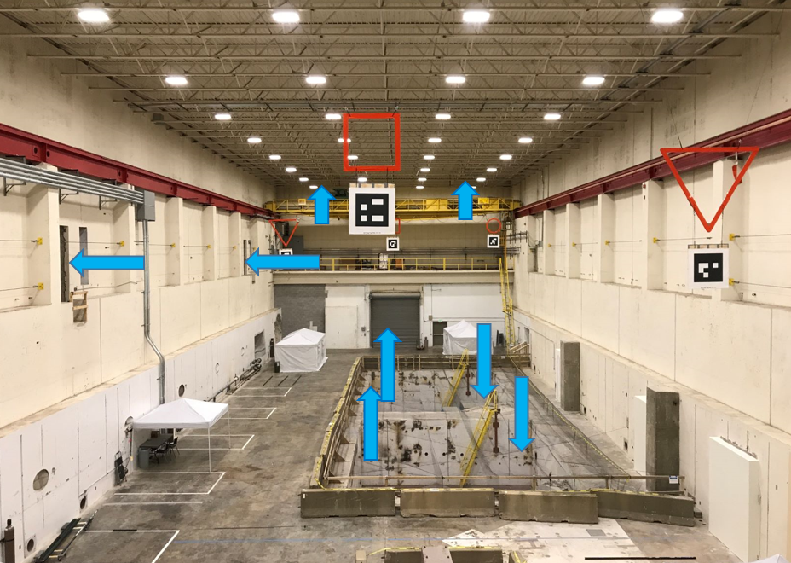

Figure 2: Playing field with draft directions roughly defined. (Note, goals have changed)

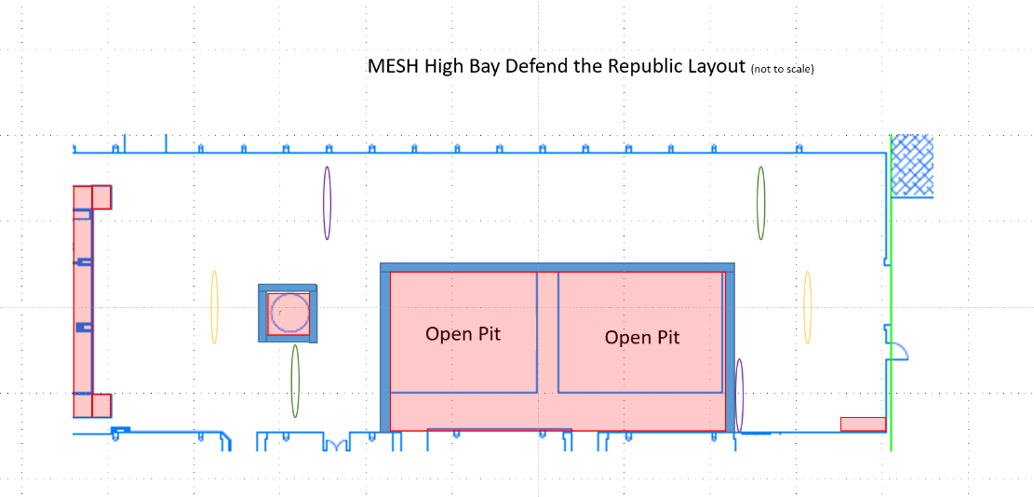

Figure 3: MESH top view with approximate goal locations

Figure 4 shows the goal set-up from the November 2021 competition. The relative location of the goals will remain the same, including the colors. The orange goals are located on the north side of the building. The yellow goals are located on the south side of the building. The April Tags will NOT be mounted on the goals.

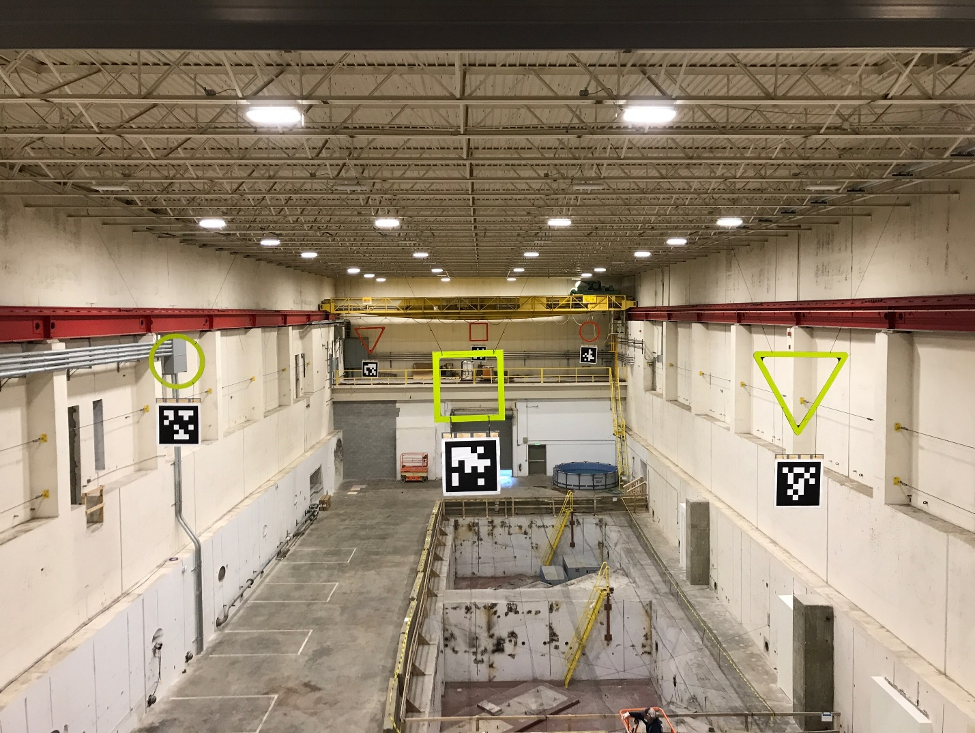

Figure 4: Nov 2021 Goal Set-Up (Note: No goal tags no longer used.)

# Supplies

## Shipping Items

Shipped items are recommended to have a planned arrival date by the Thursday prior to the start of the event to ensure readiness. All items shipped shall have a tracking number; once a tracking number is received, please provide it to Scott Hein (sdhein@indiana.edu) and Samantha Lawrence (Samantha.lawrence@navy.mil) via e-mail. A short description of what was shipped (box x size or black pelican case, etc.) is appreciated. Items shipped early will be stored in the high bay of the MESH until the event. Ship material directly to Scott Hein using the following address:

LTA

Attention – Scott Hein

2401 N. Milo B. Sampson Ln

Bloomington, IN 47408

## Router

Teams are responsible to bring their own router if they require LAN for any operations or communicating with their LTAs.

## Tools

Some tools are available on-site, but it is recommended teams bring their own tools. If specific needs are expected, please reach out to the event coordinator to see if they will be available on-site.

# Facility Safety Rules

* 1. Only authorized personnel from IU will have access to the upper / lower levels of the high bay.
  2. IU building/Facilities personnel will attempt to retrieve any items that get stuck as soon as possible and return the respective owner. Participants should ensure that they have adequate spare parts as the recovery effort may not be completed until the conclusion of the activities.
  3. Personnel shall not sit on the concrete barriers.
  4. Personnel shall not use the ship’s ladders located in the high bay.
  5. Personnel shall follow all posted signage for restricted areas.
  6. Helium gas cylinders will be secured to walls or other suitable object when in use.
  7. Helium gas cylinders will be secured in a limited access exterior compressed gas storage area when not in use.
  8. Each team will be provided a 10x10 canopy/tent over the team work area in the completion arena to mitigate hazards from airborne hazards.